Assignment -2

Functional Programming (basic exercises)

Question 1 & 2

var x_1=window.prompt("enter value for function1 and function2");
var k,l;
function square_1(x_1)
{
return x_1*x_1;
}
function double_1(x_1)
{
return x_1*2;
}

function composedValue()
{
k= square_1(double_1(x_1));
console.log("The value of compose(square,double) is "+k);
l=double_1(square_1(x_1));
console.log("The value of compose(double,square) is "+l);
}
composedValue();

Question 3

var bool;

function isEven(x)
{
bool=((x%2)==0);
}

var a=prompt("elements of array");

function find(a)
{
for(i=0;i<=a.length;i++)
{
isEven(a[i]);
if(bool==true)
{
console.log("The first even number in the list "+a[i]);
break;
}
}
}

find(a);

Question 4

var bool,boo;

function square(x)
{
bool=x*x;
}

function sqrroot(x)
{
boo=Math.sqrt(x);
}
var a=[1,2,3,4];
var b=[1,4,9,16];

function find_squares(a)
{
for(i=0;i<a.length;i++)
{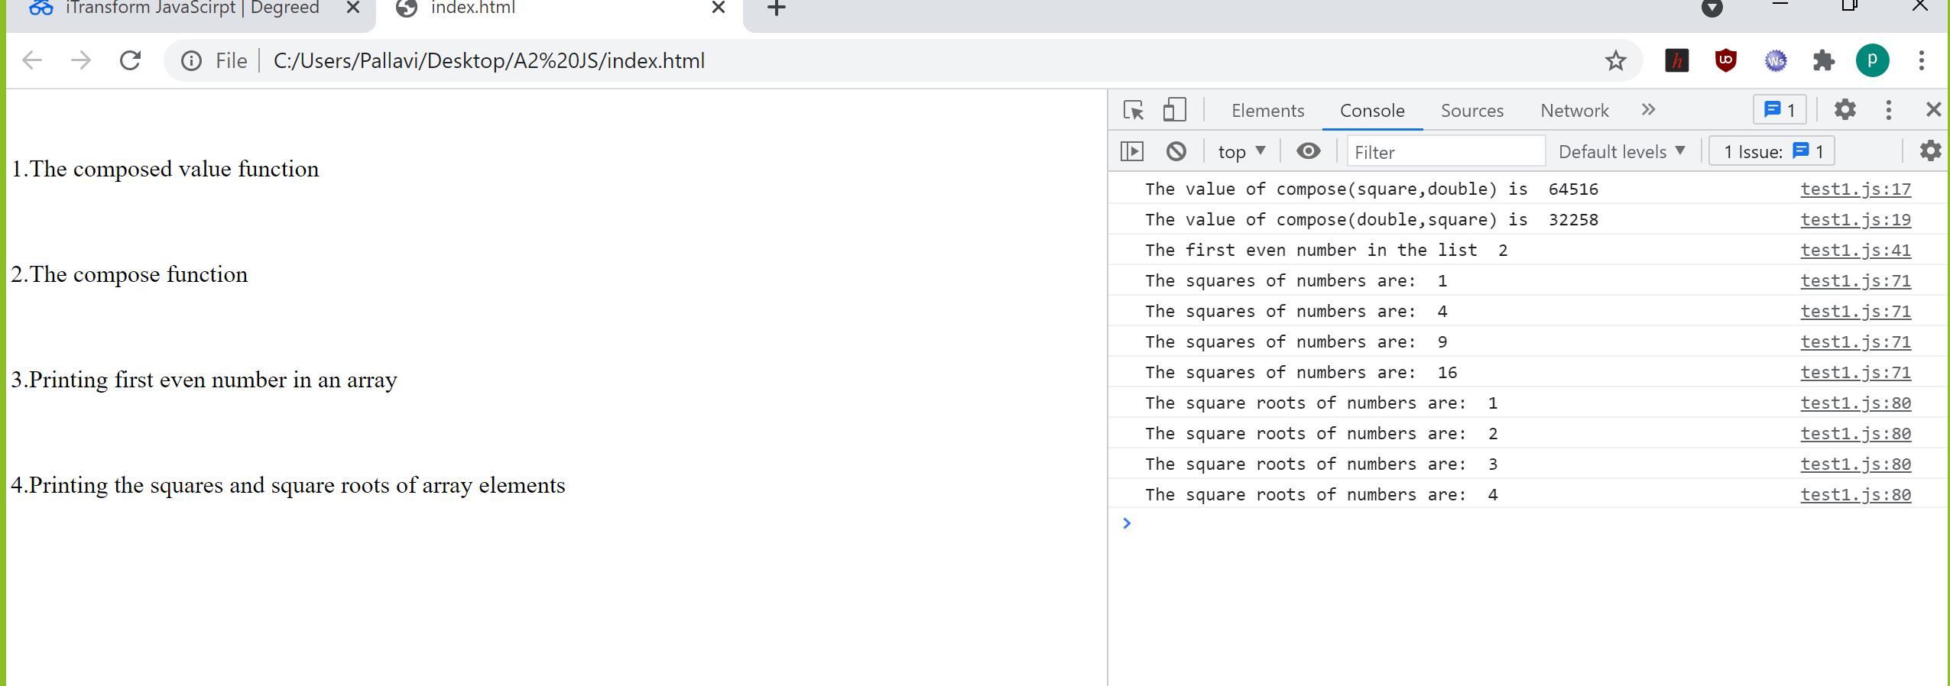
square(a[i]);

console.log("The squares of numbers are: "+bool);
}
}
function find_sqrroot(b)
{
for(i=0;i<b.length;i++)
{
sqrroot(b[i]);

console.log("The square roots of numbers are: "+boo);
}
}
find_squares(a);
find_sqrroot(b);

ADVANCED EXERCISES

1.
<!DOCTYPE html>
<html>
<head>
<title>
recursive isEven
</title>
</head>
<body>
<div class="some"></div>
<script>
var array=[1,2,3,4,5];
function isEven(num)
{
if(num%2==0)
{
return true;
}
else
{
return false;
}
}
function map(array,isEven)
{
for(i=0;i<array.length;i++)
{
var res=isEven(array[i]);
document.write("The value "+array[i]+" is "+res+"<br>");
}
}
map(array,isEven);
</script>
</body>
</html>

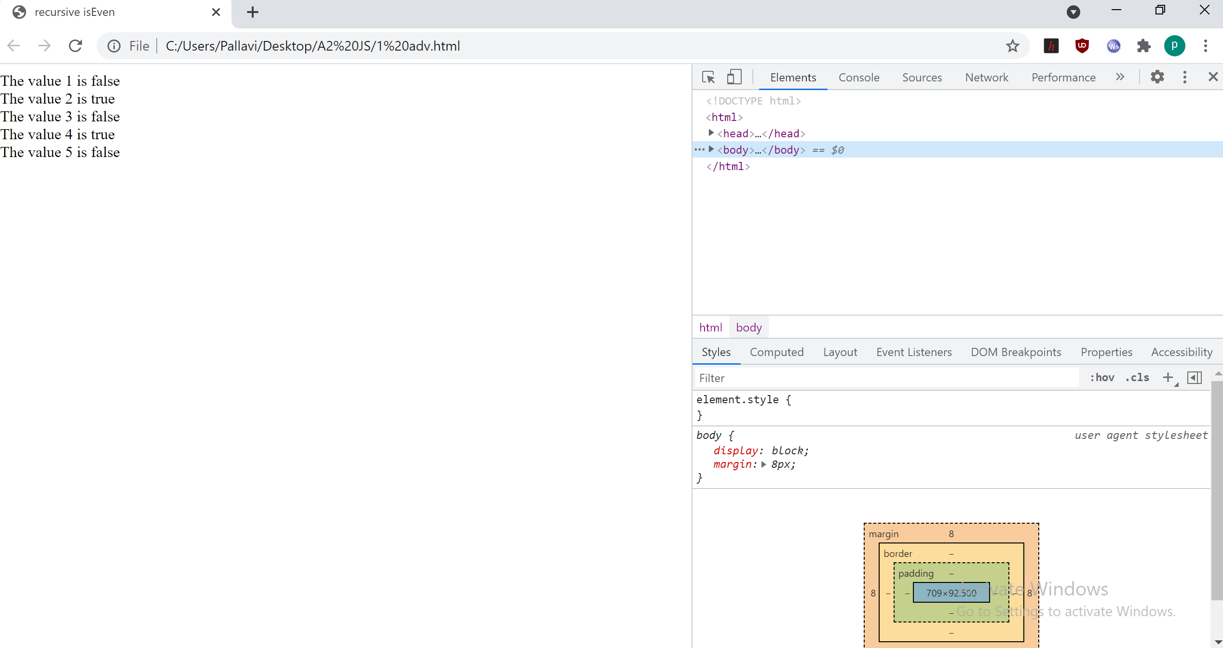
2.
<!DOCTYPE html>
<html>
<div id="find"></div>

<script>
var arr1=[1,2,3,4,5,];
var arr2=[1,4,9,16,25];
function square(x)
{
return x*x;
}
function root(x)
{
return Math.sqrt(x);
}
function map(arr1,square)
{

document.write("The values of squares are :["+b+"]<br>");
}
function map(arr2,root)
{
var b=new Array();
for(i=0;i<arr1.length;i++)
{
var res=root(arr2[i]);
b[i]=res;
}
document.write("The values of square roots are :["+b+"]<br>");
}

map(arr1,square);
map(arr2,root);

</script>
</html>

